Introduction
This document explains how to use entities2Wiw node.
entities2Wiw allows to declare entities onto What Is What.

The flow
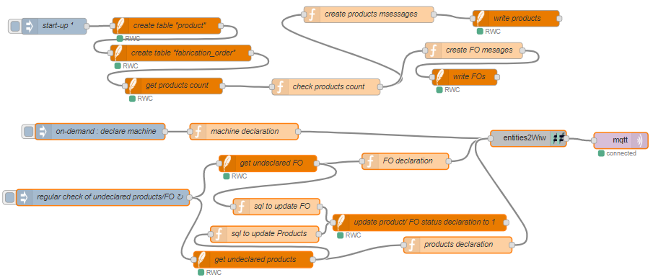
This flow has been created with node v10.16.0 and Node-RED v0.20.7.

Third party dependencies
A Mqtt broker must be running. See mqttBroker document for more information.
In this example we use the database to simulate for example an ERP.
This example relies on an included database. To handle the database access, dedicated nodes are needed. Node-red-contrib-sqlite is used and must be installed. The database file will be automatically created into your Node-RED personal folder.

Explanation
This flow demonstrates how to use entities2Wiw to declare news entities onto What Is What.

First line
The first line is setup to start 1 second after Node-RED start. It creates and fills a database with products and fabrication orders (FO).

Second Line
The first inject node declares a machine by creating the required Javascript object. This could also be loaded from a file, … (not in this example).
The second inject node checks every 2 seconds if there are undeclared products or FO into the database. New products or FOs are then declared onto What Is What.

Note
Please make sure to use the right Mqtt broker settings in the Mqtt client setup.

